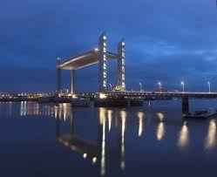

**Pont Jacques Chaban-Delmas Bridge**

The Pont Jacques Chaban-Delmas is a vertical-lift bridge over the Garonne in Bordeaux, France. It was inaugurated on 16 March 2013 by President François Hollande and Alain Juppé, mayor of Bordeaux. It’s main span is 110 m (361 ft) long. As of 2013, it is the longest vertical-lift bridge in Europe.[1] It is named in honour of Jacques Chaban-Delmas, a former Prime Minister of France and a former mayor of Bordeaux.